A BERRY FARM(ER) IS BORN

Cathy Heidenreich, Western NY Berry Extension Support Specialist, Department of Horticulture, Cornell CALS and Daniel Clement, Dan’s Berry Patch, Ithaca, NY

Daniel Clement, owner/operator of “Dan’s Berry Patch”, Ithaca, NY, joined the ranks of New York berry growers this season when he put in 1/3 acre of new berries including summer and fall red raspberries (550), blueberries (42) and a handful of currants, gooseberries, and elderberries. Dan recently hosted a grower twilight meeting at his new planting where he shared his experiences in getting a new berry farm up and running.

“This year is an investigation into berry farming for me. I intend to learn more about growing berries, analyze markets, experiment with value-added products, consider expansion, work on a business plan, investigate the availability of labor, and to see how well I like farming after doing it a year”

A Berry Difficult Decision?
Dan, recently retired from his 25 year career as art restoration specialist (paper) has always had an interest in farming. He has especially fond memories of his father’s collection of Gravely cultivators and tillers, some of which are still in use on Dan’s farm today. The decision to grow raspberries on a larger scale stemmed from his love both of the fruit and of outside work but Dan was determined from the get go not to have to spend as much time hand –weeding/hoeing his commercial planting as he had the raspberries in his home garden (oh my aching back…).
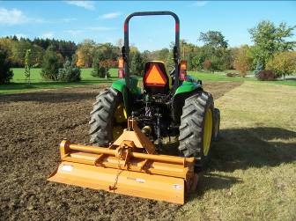
Getting a Toe in the Water
Checking out available resources…planning out the planting…attending an introduction to berry growing meeting and other workshops, having a soil test done – Dan spent a lot of time doing the legwork before he ever put a plant in the ground. He relied heavily upon the NRAES Bramble Production Guide for information. Dan began preparing his new planting (previously a lawn area) in late October 2007 by killing the sod with glyphosate herbicide and tilling the soil.

Dan’s 6’ Woods rotary tiller with JD 4120 tractor. Note killed sod, right.

Rye was planted after soil preparation was complete to add organic matter to the soil and help suppress weeds. The following spring glyphosate was applied to the rye. The killed cover crop was then cultivated into the soil to add organic matter. Planting began on May 6th and was completed on May 8th.

Only the Berry Best Will Do
Dan spent a lot of time reading up on various varieties and getting advice on which ones to plant in his area. Fall-bearing raspberries he selected for his planting include Jaclyn and Himbo Top. Summer-bearing raspberries include Nova, Prelude, Kilarney, and Encore. Blueberries include Blueray, Patriot, and Jersey. Other berries in the planting are Ben Sarek black currant, Hinnonmaki red gooseberries and Samdahl elderberries.

Convinced he needed to be able to provide adequate moisture for his new berry planting, Dan began to think bout possible sources of water. The main source of water for the berry patch is primarily pond water, hauled ½ mile by tractor and trailer, 500 gallons at a time. Water from an old farm well serves as a secondary source. In early June this well was producing about 150 gallons a day, which Dan pumps into holding tanks until sufficient water is accumulated to water the berry patch. Approximately every 3 days the well provides sufficient irrigation water for the planting, saving Dan one of the daily ½ mile trips to the pond for water.

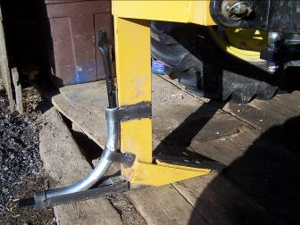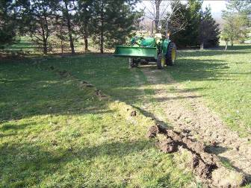
Modified soil subsoiler Trench for supply line

Supply pipes were laid 4-6” deep using a subsoiler custom-modified by Dan to bury hose. This was done by welding galvanized electrical conduit with a 90 degree angle bend to the subsoiler. The general idea for this is described in the NRAES publication “Trickle Irrigation”.

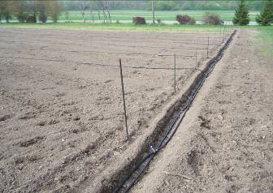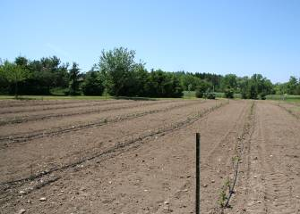
Irrigation feeder lines Completed irrigation system

Water is piped through a ¾” poly hose 400 feet to the field where it is delivered to the berry plants through heavy wall, pressure compensating dripper tubing on a 17 mm x 24-inch spacing at a rate of 0.4 GPH. Irrigation feed lines were set in a small trench cut by the Gravely and later buried.

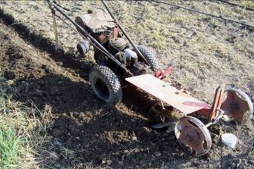
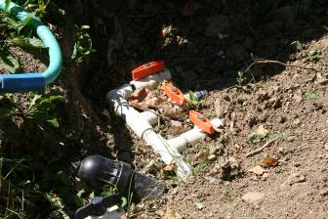
Gravely used for furrows Hand valves for irrigation zones

Dan designed the irrigation system to be divided into 3 irrigation zones controlled separately by hand valves so each section may be irrigated independently of the others if necessary. He included a removable filter in the line to help prevent clogging of dripper tubes.

Wanting to get off on the right foot with fall raspberries, Dan decided to install a removable T trellis system for their support. Using a post hole digger Dan dug 24-30-inch deep holes every 25 feet down the rows destined for fall raspberries. Sections of 10-ft x 4” PVC pipe were cut to 30” and set into the holes. These in-ground pipes will hold 3 x 4 PT landscape timber uprights (or 4 x 4s). When not in use, they may be capped with tapered cement plugs to keep them open. This whole trellis may be lifted up out of the in-ground PVC holders and set aside so canes may be mown down in late winter/early spring.

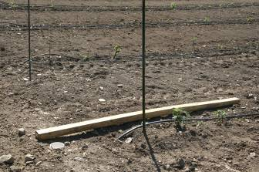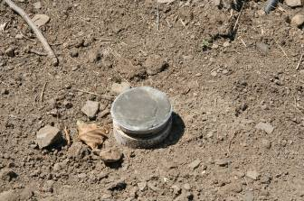
PVC in-ground holder and trellis upright Tapered cement plugs for PVC trellis holders

Another must for the berry patch, Dan decided, was deer fence. The fence is 8 ft high with 4 foot high 2” x 4” welded wire at the bottom to keep out smaller mammals. Above that is smooth high tensile wire installed at 1-ft intervals to discourage deer traffic. Some posts are black locust cut from Dan’s property and others are pressure treated 4 x 4’s. Horizontal and vertical corner supports are done with inexpensive 8-ft pressure treated semi-rounded landscape timbers from Home Depot (3 x 4-in.). The posts are set in the ground from 30-42” depending on how many rocks were encountered! Each post was set in concrete: 1 80-lb bag for corners and shallow set posts; ½ bag for all other line posts. Dan noted that he had already had one deer run into the fence, making a nice dent in the welded wire, but apparently leaving the deer [apparently] unscathed. He added flagging tape to the top of the welded wire fencing as a warning to the resident deer population.

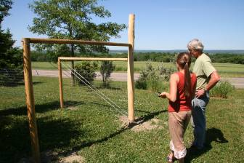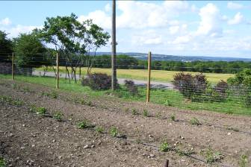
Dan and Molly Shaw, South Central Ag Program, discuss the Welded wire fencing lines the bottom of the deer fence.
deer fence.

Raspberry Killed Cover Crop Planting
As if first year berry farm operations were not enough of a challenge, Dan volunteered to participate in a raspberry killed cover crop demonstration sponsored by the NYFVI and NY Berry Growers Association. The no-till raspberry trial is one part of a larger research and extension project on improving berry crop production efficiency in NYS. Since Dan had already planted a rye cover crop the previous fall, everything was in line to try out a no-till raspberry planting method. The fall-bearing raspberries were his choice for this trial. Side-by-side plantings were made with one row each of Himbo Top and Jaclyn planted conventionally or in killed cover crop.

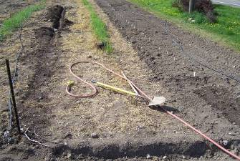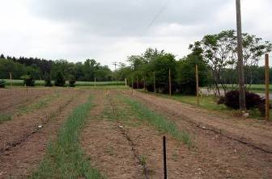
Side-by-side comparison at planting. Side-by-side comparison, week 2.

Dan noted that the soil moisture was higher in the no-till area at the time of planting. He did not observe a difference in growth rate or improved weed suppression, but says that his rye was planted late and was probably too thin to be a fair test of the theory that mulch from the rye could be used to advantage.

Many thanks to Dan for participating in the NYFVI project, hosting the twilight meeting, and sharing details and photos of his new berry operation with us. Details on the raspberry killed sod planting method follow below

If you are planning to plant raspberries in 2009 we would welcome your participation in a raspberry killed sod and/or biofilm demonstration project. For more information please contact Cathy Heidenreich (Western NY) at 315-787-2367, mcm4@cornell.edu, or Laura McDermott (Eastern NY), 518-746-2562,
RASPBERRY KILLED COVER CROP PLANTING METHOD
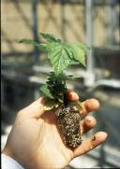
Year before planting
Do a soil test, prepare the soil, add amendments, and establish a rye cover crop (40Lb/A) the fall before planting raspberries.

Planting year
In spring, use glyphosate herbicide to spray out 3 foot wide strips in rye 2-3 weeks prior to planting. Note: If rye is very tall (3-4 ft) mow prior to spraying strips; the rye should be mowed high, 8-10”.

Open a furrow down the center of the killed sod strip. Plant dormant raspberry canes into the furrow. Water plants in well.
A light covering of straw mulch may be applied over residue after planting to help keep weeds down. Note: If tissue culture plug plants are used, a re-chargeable drill with wood drill bit the diameter of the plug plant can be used to open planting holes instead of using furrows to further reduce weed growth.

Mow rye middles once or twice to prevent them from going to seed. After the rye is dead, disc alleyways to loosen soil. Overseed prepared middles with a perennial rye or short fescue to establish permanent sod middles in late summer to early fall.
Roll or disc after seeding to work seed down into soil.

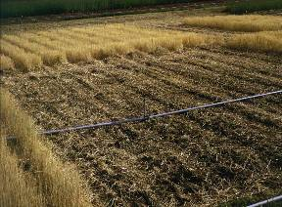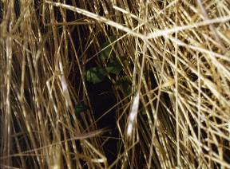
Research trial before planting, bare ground and killed cover crop At planting, tissue culture plug plant in killed cover crop

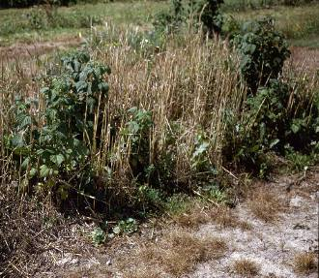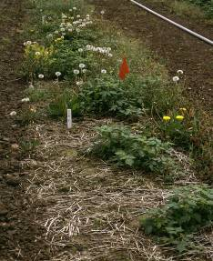
Raspberries growing up out of killed cover crop. Year 2 killed cover crop (front), few weeds. Very weedy conventional planting, rear.

