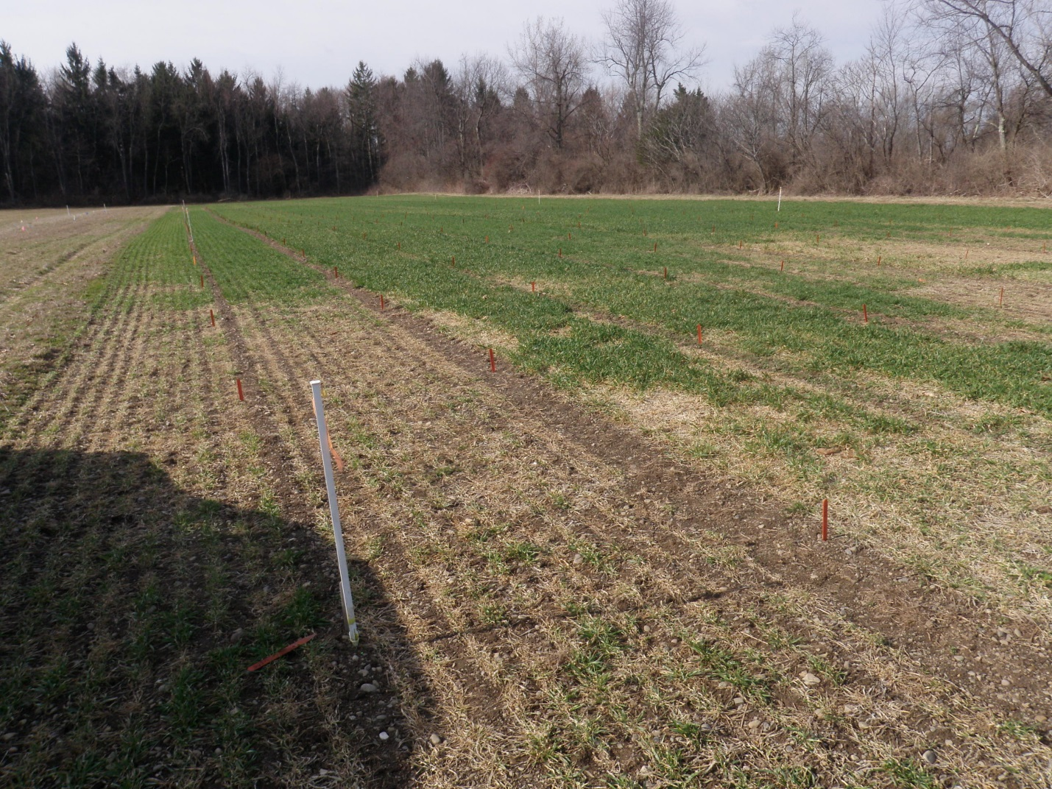

The impact of snow mold can be clearly seen in this photo at the Cornell Valatie Research farm. Snow mold is a geographic phenomenon in that it occurs in the lower areas of the field where spring thaw accumulates on frozen ground. The NYFVI supported research clearly has shown it is it NOT a function of planting early or late, or of high nitrogen or low nitrogen. To the left of the stake it was planted late with no nitrogen. Immediately to the right of the stake it was planted late with high nitrogen. The second plot to the right of the stake was planted early with high nitrogen. It appears wherever the vegetation is covered by water, snow mold occurs. The early planted plot had some taller vegetation that was above the water and so survived the snow mold.

